**Computer and Information System**

**Coursework Assessment**

**202010**

|  |  |  |  |
| --- | --- | --- | --- |
| **Course** | ICT-2013 Computational Thinking and Coding. | | |
| **Assessment Method** | Group Project | | |
| **Date of Assessment** | Handout: Week 11  Submission: Week 14 | **Duration / Deadline(s)** | 3 Weeks |
| **Maximum Mark** | 100 | **Percentage of Final Grade** | 25% |

|  |
| --- |
| **Instructions to Students**   1. This assessment has. # pages including the cover page. 2. A group must contain 2 to 4 students. 3. Each student is required to submit the project deliverables individually onto Blackboard. |

|  |
| --- |
| **Academic Honesty Statement**  **In accordance with HCT policy LP201- Academic Honesty**  **• Students are required to refrain from all forms of academic dishonesty as defined and explained in HCT procedures and directions from HCT personnel.**  **• A student found guilty of having committed acts of academic dishonesty may be subject to one or more of the disciplinary measures as outlined in Article 33 of the Student and Academic Regulations.**  إفادة الأمانة الأكاديمية  **وفقًا لسياسة كليات التقنية العليا - LP201 الأمانة الأكاديمية**  **• يُطلب من الطلبة الامتناع عن كافة أشكال سوء الأمانة الأكاديمية، كما هو مبيّن وموضح في السياسات والإجراءات الخاصة بكليات التقنية العليا، والتوجيهات الصادرة من موظفي الكليات.**  **• في حالة ارتكاب الطالب أي شكل من أشكال سوء الأمانة الأكاديمية سوف يتعرض الى واحد أو أكثر من التدابير التأديبية على النحو المبين في المادة 33 من الأنظمة الأكاديمية.** |

|  |  |  |  |
| --- | --- | --- | --- |
| **Student ID** | **Student Name** | **Student ID** | **Student Name** |
|  | 1. |  | 3. |
|  | 2. |  | 4. |

|  |  |  |  |  |  |
| --- | --- | --- | --- | --- | --- |
| **Question (Section) No.** | **Deliverable 1** | **Deliverable 2** | **Oral Defense** | **Total** | **%** |
| **Marks Allocated** | 35 | 15 | 50 | **100** | **25** |

Note to students- Please read and then delete/replace the writing in yellow and complete all parts.

# Project Introduction

Describe all the essential information related to the background of your proposed Data Analysis. Minimum 200 words

- Description of the purpose of the project – Aim of the project.

In this project, we are going to work with the COVID19 dataset, published by John Hopkins University, which consists of the data related to the cumulative number of confirmed cases, per day, in each Country. This dataset is interesting because it is highly structured and yet somewhat messy in ways that meaningfully relate to real-world problems. In the assinment, we will use Python libraries such as Pandas and Matplotlib to download, clean, analyze and visualize the coronavirus open dataset from the institute . this assignment/project puts together the skills we learned in the previous Python lecture which was deliverd the institute and apply them on real data through the whole data wrangling workflow.. Using [Python](https://opensource.com/resources/python) and some graphing libraries, you can project the total number of confirmed cases of COVID-19, and also display the total number of deaths for a country (this article uses India as an example) on a given date. Humans sometimes need help interpreting and processing the meaning of data, so this article also demonstrates how to create an animated horizontal bar graph for five countries, showing the variation of cases by date.

# Analysis OBjectives

List the questions (at least 7) of the Project. These questions should be relevant, by providing useful information that may help in taking decisions.

# Data Acquisition and Cleaning

Code to read the data from Excel / CSV / HTML.

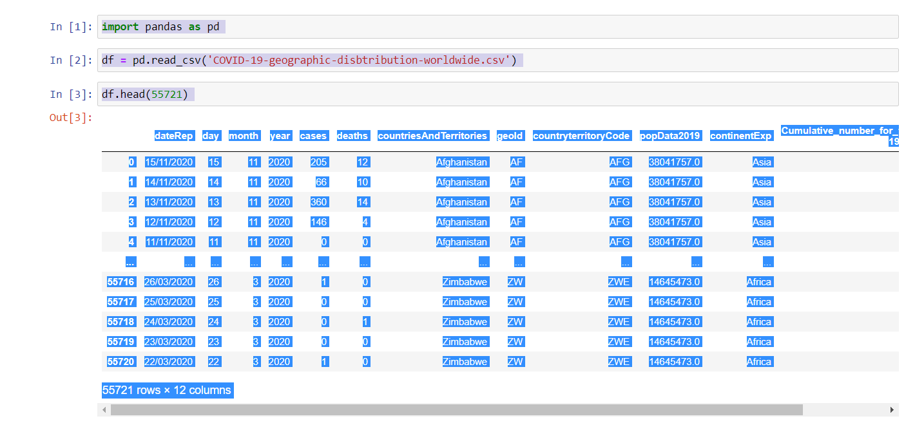

Clean the unnecessary data, by removing, replace the missing data and renaming the columns.

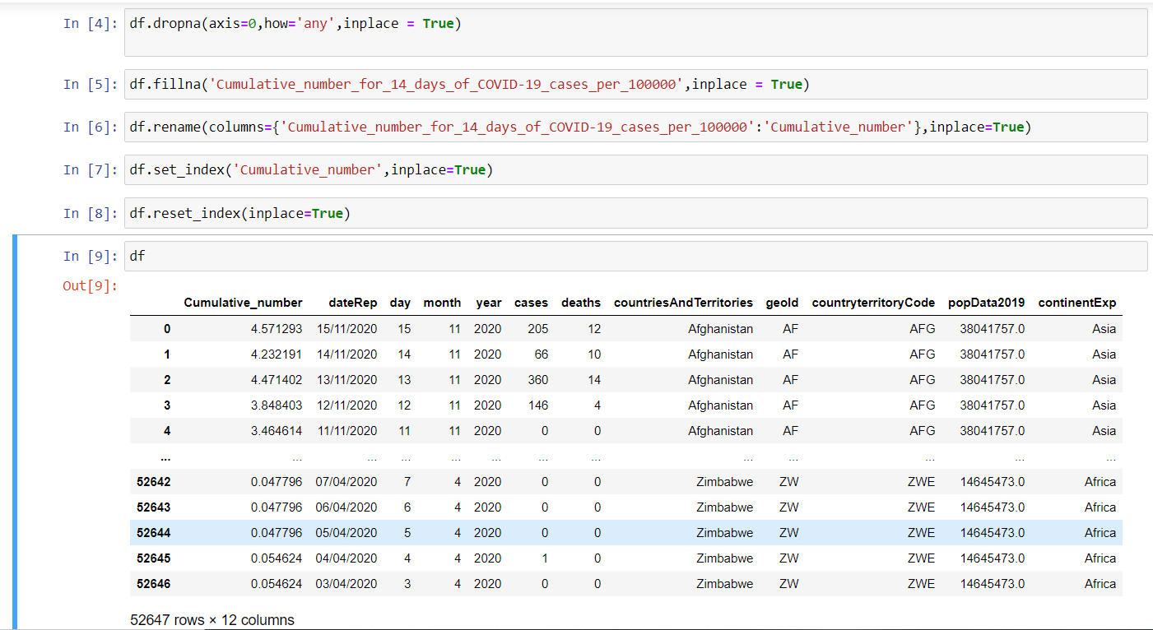

Explanation of why data clean needed (for your data).

It's **important to clean** up your **data** because dirty **data** will lead to dirty analysis and dirty predictions.

# Data and Exploratory Analysis

Screen Shot of the code and its output with explanation of how your data analysis meet the project objectives and produced the required findings as per the project specification.

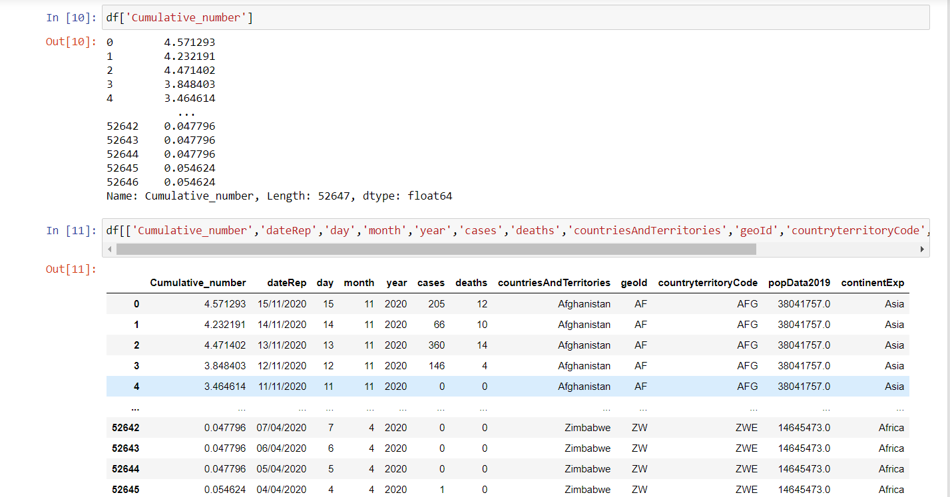

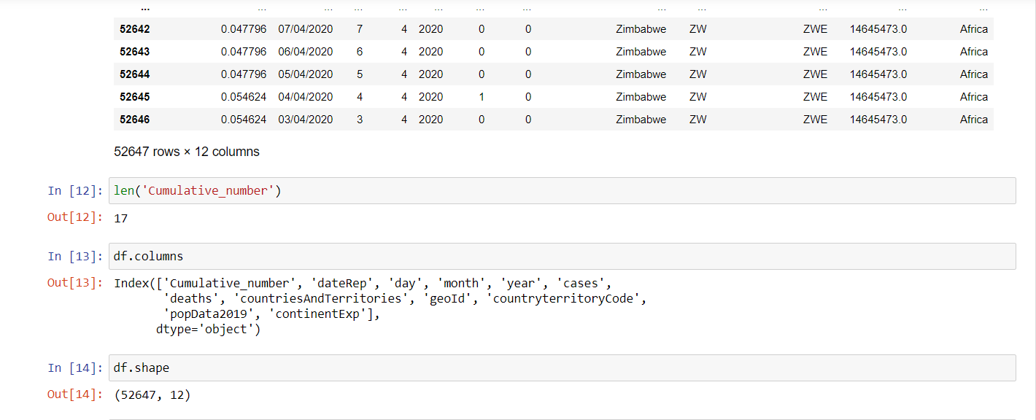

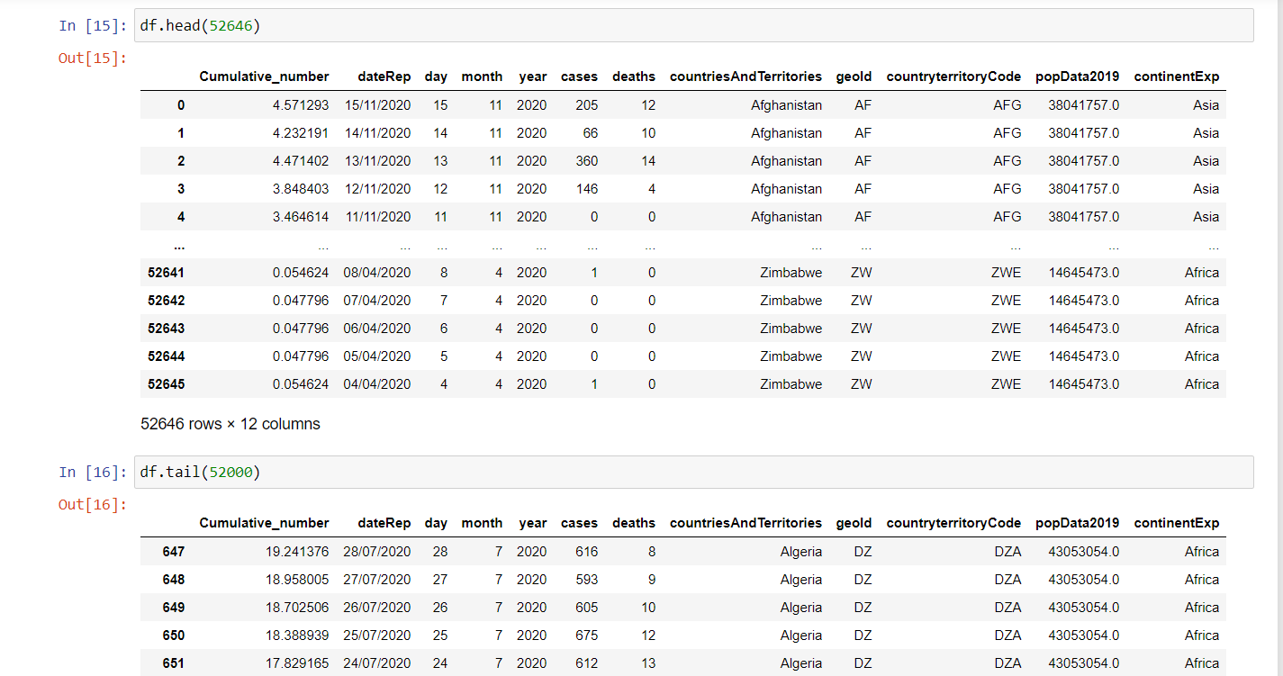

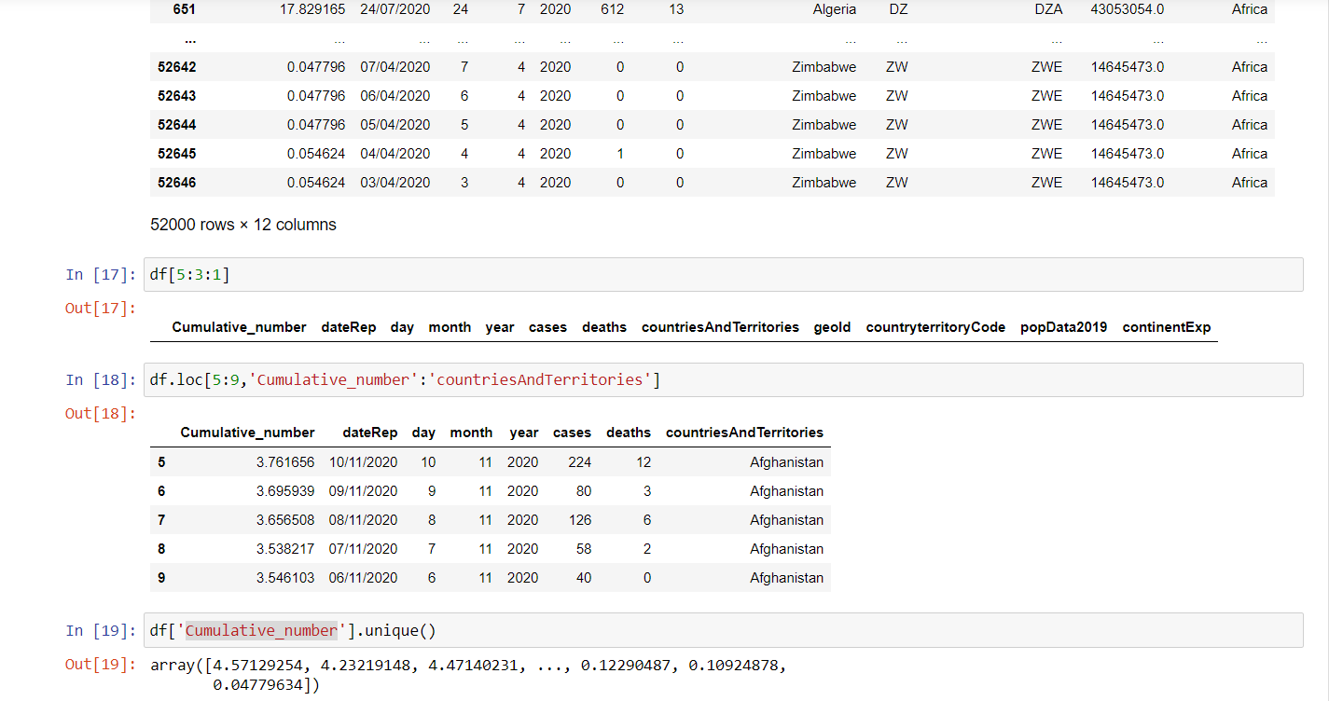

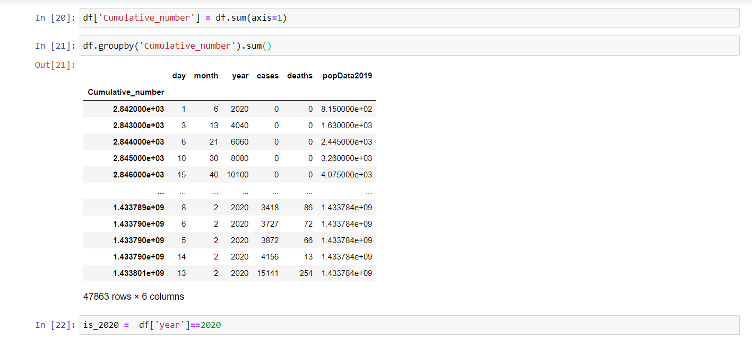

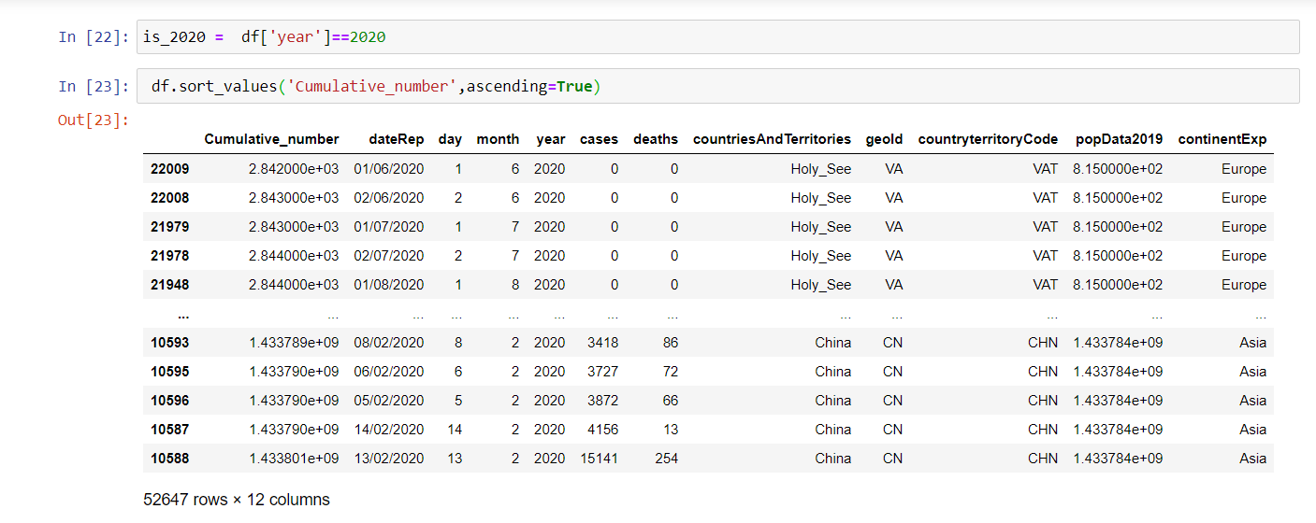

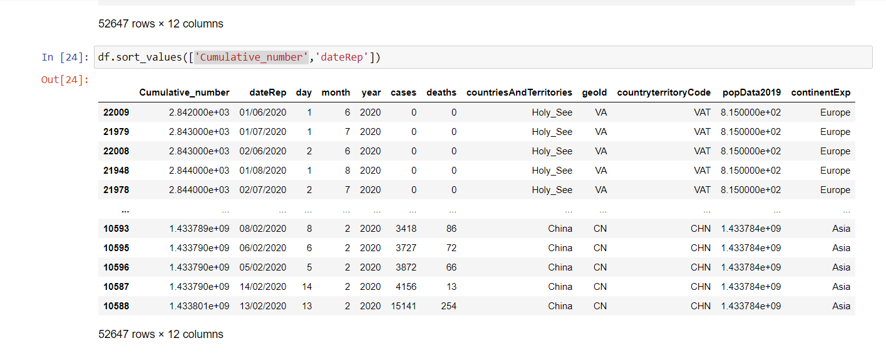

This part of analysis must include – Statistics, Filter, Calculations, Group, Sort.

Screen Shot of the code and its output with short explanation about the data, sample rows, columns, total rows, and descriptions. This part is to get familiar with your data and summarize their main characteristics

# Data Analysis - Visualization

Screen Shot of the code and its output with explanation of how your findings can be visualized.

This part of analysis must include – Code and output of the Plot Graph(s) with appropriate colour, title, x-axis and y-axis, with explanation of the findings. Use different types of appropriate charts to meet your objectives.

process to do the data analysis.

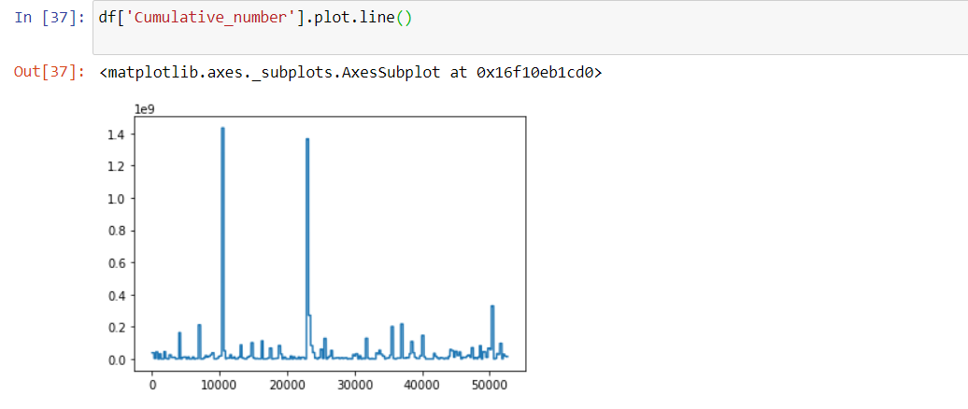

# Executive Summary

Write a executive summary for minimum 200 words that summarize your findings and include what are the pro and cons of the data / system. Write your recommendations that could benefit / improve the process / system.

In this project, we are going to work with the COVID19 dataset, published by John Hopkins University, which consists of the data related to the cumulative number of confirmed cases, per day, in each Country. This dataset is interesting because it is highly structured and yet somewhat messy in ways that meaningfully relate to real-world problems. In the assinment, we will use Python libraries such as Pandas and Matplotlib to download, clean, analyze and visualize the coronavirus open dataset from the institute . this assignment/project puts together the skills we learned in the previous Python lecture which was deliverd the institute and apply them on real data through the whole data wrangling workflow.. Using [Python](https://opensource.com/resources/python) and some graphing libraries, you can project the total number of confirmed cases of COVID-19, and also display the total number of deaths for a country (this article uses India as an example) on a given date. Humans sometimes need help interpreting and processing the meaning of data, so this article also demonstrates how to create an animated horizontal bar graph for five countries, showing the variation of cases by date.

# References

Include all the external references that you might have used. APA / MLA referencing style may be used. If you’re not aware of MLA or not fully confident in using it, refer to the library resources including librarians.